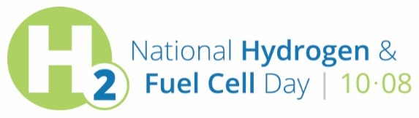
Sample Newsletter / Blog Post for Members

[Organization] Celebrates National Hydrogen and Fuel Cell Day

- On October 8th, [Organization] will join the nation in celebrating National Hydrogen and Fuel Cell Day to raise awareness of the fuel cell and hydrogen industry, technologies that are providing reliable and resilient power to a range of market sectors, while strengthening America’s energy, environmental, and economic security.

National Hydrogen and Fuel Cell Day is observed on October 8 (10.08) in recognition of the atomic weight of hydrogen (1.008). Efficient, clean, and quiet, fuel cells generate electricity through a chemical reaction of hydrogen and oxygen, without combustion.

Today the fuel cell and hydrogen footprint is making an impact for a long list of customers in many applications and markets. Consumers are driving their choice of several fuel cell vehicles from major automakers, fuel cell buses are in revenue service in several states, a budding network of dozens of hydrogen fueling stations are open for business in California and currently under development in other states, tens of thousands of fuel cell-powered forklifts are working around the clock in America’s warehouses and factories, and hundreds of megawatts of fuel cells are powering data centers, communications networks, retails sites, and municipal facilities across the country.

Zero-emission fuel cell vehicles and fuel cells for power generation are dramatically reducing emissions compared to combustion technologies, and offer a range of other benefits, helping lead our country to a more environmentally-friendly and secure future.

For more information on National Hydrogen and Fuel Cell Day, please visit to www.hydrogenfuelcellday.org.

###

